**Assessment Cover Page**

|  |  |
| --- | --- |
| *Student Full Name* | Yumiko Maria Bejarano Azogue |
| *Student Number* | 2024144 |
| *Module Title* | Strategic Thinking |
| *Assessment Title* | Capstone Project Proposal |
| *Assessment Due Date* | 19th May 2024 23:59 |
| *Date of Submission* | 23.04.2024 |

**Declaration**

By submitting this assessment, I confirm that I have read the CCT policy on academic misconduct and understand the implications of submitting work that is not my own or does not appropriately reference material taken from a third party or other source.

I declare it to be my own work and that all material from third parties has been appropriately referenced.

I further confirm that this work has not previously been submitted for assessment by myself or someone else in CCT College Dublin or any other higher education institution.

Contents

CA1: 1

Project proposal 1

Introduction 1

Objectives 1

Problem definition 1

Scope and Methodology 2

Scope 2

Methodology 2

Ethical considerations 3

CA2: 4

Project management and planning 4

Data Source Overview 4

Project Plan 4

Timeline 5

Project Plan Timeline - Execution 6

Data Exploratory Data Analysis (EDA) 7

Data Description 7

Summary Statistics: 7

Data Visualization: 8

Model Performance: 10

Pre-processing 10

Implementation and Evaluation of Machine Learning Models 11

Classification Models: 11

Development K Nearest Neighbors (KNN) - model with the best accuracy score 12

Visualization of the Confusion Matrix: 13

Conclusion 14

Recommendations 14

Github 14

References 15

**Gender workforce participation**

# CA1:

## Project proposal

### Introduction

This report focuses on analyzing workforce participation, with the aim of verifying the existence of gender disparities. We will examine the challenges and opportunities faced by individuals based on their gender in various job roles and positions.

Women face persistent gender barriers, the lack of role models and stereotypes that perpetuate gender inequality in this field, to quote the civil rights activist Marian Wright Edelman, “You can’t be what you can’t see”.

### Objectives

#### General Objective:

To investigate and understand the gender gap in the workforce, focusing on the participation of men and women in different job roles and positions.

#### Specific Objectives:

* Analyze the gender distribution in different job roles, including positions and departments.
* Investigate the relationship between age and workforce participation for men and women.
* Evaluate workforce performance and its relationship with gender.
* Explore the relationship between education and gender distribution in the workforce.

### Problem definition

The existence of gender disparities in the workforce can affect equity and equal opportunities. It is important to identify and understand these disparities to implement measures that promote gender equality and inclusion in the workplace.

## Scope and Methodology

### Scope

This project will analyze data related to job roles, gender, age, workforce performance, education, and other relevant factors. We will investigate patterns and trends in gender distribution across different job roles and departments, as well as their relationship with age, workforce performance, and educational level.

### Methodology

For this project, we will use the CRISP-DM methodology (Cross-Industry Standard Process for Data Mining):

Business Understanding:

* Identify business objectives.
* Determine data mining goals aligned with business objectives.
* Define success criteria.
* Develop a preliminary plan to achieve objectives.

Data Understanding:

* Gather relevant data sources.
* Explore data to understand its quality, content, and structure.
* Identify data issues, anomalies, and potential biases.
* Determine data requirements for modeling.

Data Preparation:

* Clean and preprocess data to handle missing values, outliers, and inconsistencies.
* Select relevant features for analysis.
* Transform and engineer features as needed for modeling.
* Split data into training and testing sets.

Modeling:

* Select appropriate modeling techniques based on data characteristics and objectives.
* Build initial models using selected techniques.
* Evaluate model performance using relevant metrics.
* Fine-tune models by adjusting parameters and algorithms.

Evaluation:

* Assess model performance against success criteria and business objectives.
* Validate models using cross-validation or holdout datasets.
* Interpret model results and identify areas for improvement.
* Document findings and recommendations for stakeholders.

### Ethical considerations

Identifying potential biases:

* Examine the data and models to identify any inherent biases.

Assessing potential impact:

* Evaluate how potential biases could affect different user groups or individuals impacted by the decisions made by the model. Consider whether bias could result in discrimination or injustice towards certain groups.

Mitigating identified biases:

* Implement strategies to mitigate the identified biases. This could include gathering more representative data, designing more equitable algorithms, and incorporating checks and procedures to prevent biased decisions.

# CA2:

## Project management and planning

### Data Source Overview

The dataset was obtained from Kaggle and focuses on incomes for various job titles by gender. Below is the link to access the dataset.

<https://www.kaggle.com/datasets/nilimajauhari/glassdoor-analyze-gender-pay-gap>

Data has been released under a CC 2.0 license:  <https://creativecommons.org/licenses/by/2.0/>

### Project Plan

Business Understanding:

* Identify project objectives and key research questions.
* Establish success criteria and define the project scope.

Data Understanding:

* Select and acquire the dataset on women in the technology industry.
* Explore the data to understand its quality, content, and structure.
* Identify potential data issues and biases.

Data Preparation:

* Clean and preprocess the data to handle missing values, outliers, and errors.
* Select relevant features and transform them as necessary for analysis.
* Split the data into training and testing sets.

Exploratory Data Analysis (EDA):

* Conduct exploratory data analysis using visualization techniques and descriptive statistics.
* Identify patterns, trends, and potential insights related to women's participation in the technology industry.

Machine Learning Implementation:

* Select at least one machine learning algorithm to apply to the dataset.
* Train the model using the training dataset and evaluate its performance.
* Fine-tune and optimize the model as necessary.

Evaluation:

* Evaluate the model's performance using appropriate metrics such as accuracy, recall, F1-scor.
* Validate the model using a separate test dataset or cross-validation techniques.

Conclusion and Presentation:

* Interpret the results of the analysis and discuss implications for women's participation in the technology industry.
* Summarize key findings and provide recommendations for future research or actions.
* Prepare a detailed report and an effective presentation of the project results.

### Timeline

Semester 1: February 2024 - May 2024

* Initial Research (Week 1 - Week 4):
  + Literature review on the project topic.
  + Identification and selection of possible methods, techniques, and approaches to be used.
  + Detailed definition of project objectives.
* Data Acquisition (Week 5 - Week 10):
  + Dataset search and selection.
  + Identification of necessary permissions to access and use selected data.
  + Evaluation of integrity and quality of acquired data.
  + Data preparation for subsequent analysis, including standardization and normalization if necessary.
* Exploratory Data Analysis (Week 11 - Week 16):
  + Initial data exploration to understand its structure and characteristics.
  + Identification of possible patterns, trends, or anomalies in the data.
  + Preparation of preliminary visualizations and descriptive analysis.
* Model Development and Evaluation (Week 17 - Week 22):
  + Implementation of data analysis models or machine learning algorithms.
  + Evaluation of model effectiveness in relation to project objectives.
  + Adjustment and refinement of models as needed.

Semester 2: August 2024 - December 2024

* Optimization and Validation (Week 23 - Week 28):
  + Further optimization of selected models.
  + Cross-validation and robustness testing of models.
  + Evaluation of accuracy and reliability of obtained results.
* Conclusion Development (Week 29 - Week 32):
  + Interpretation of results obtained from data analysis.
  + Formulation of conclusions and recommendations based on project findings.
  + Preparation of preliminary reports and presentation of results.
* Refinement and Final Report Elaboration (Week 33 - Week 36):
  + Review and refinement of the final project report.
  + Incorporation of feedback and suggestions received during preliminary presentation.
  + Preparation of final presentations and additional materials for delivery.
* Final Delivery and Presentation (Week 37 - Week 40):
  + Final project presentation to evaluation committee.
  + Delivery of final project report and other related materials.
  + Closure and completion of all project-related activities.

### Project Plan Timeline - Execution

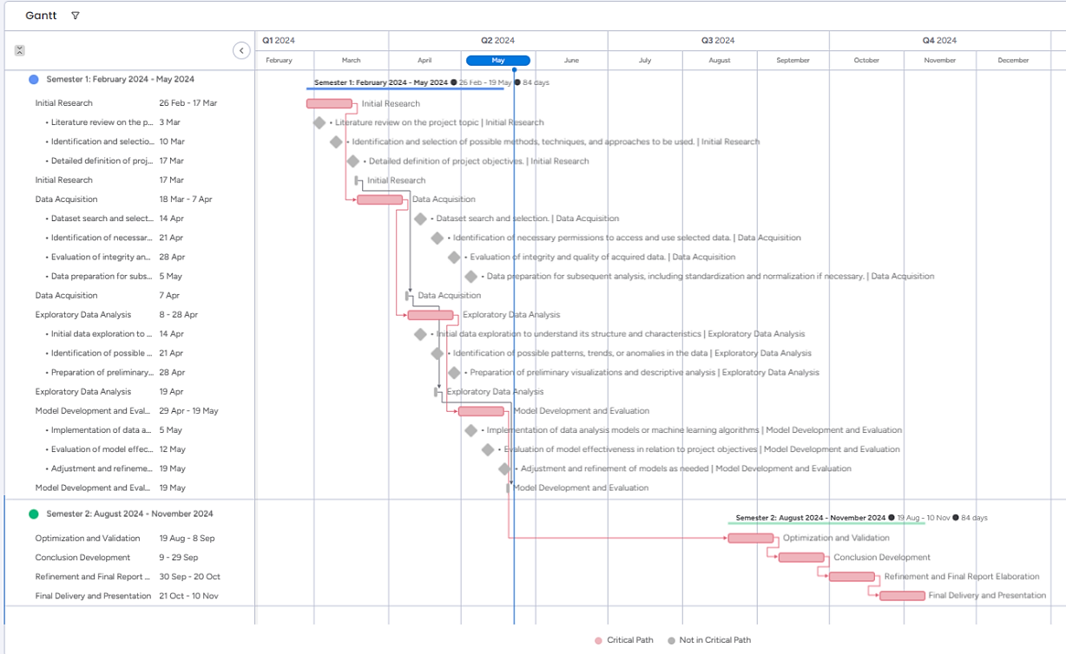





## Data Exploratory Data Analysis (EDA)

### Data Description

Dataset Size: The dataset comprises 1000 rows and 9 columns. It consists of information about employees, encompassing details such as salary, gender, position, location, education level, and work experience. Among these, there are 4 categorical variables (Gender, JobTitle, Education, Dept) and 5 numeric variables (Age, PerfEval, Seniority, BasePay, Bonus).

Structure and Variables: Upon examination, the dataset revealed a structured layout consisting of 9 variables. Among these variables, 4 are categorical (Gender, JobTitle, Education, Dept), and 5 are numeric (Age, PerfEval, Seniority, BasePay, Bonus). These variables were further analyzed to gain insights into their distributions and relationships within the dataset.

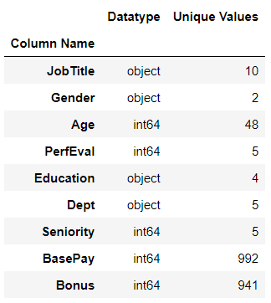

### Summary Statistics:

Descriptive statistics for numerical variables in the dataset:

* Age: The average age of individuals is approximately 41 years, with a standard deviation of around 14 years. Age ranges from 18 to 65 years.
* PerfEval: The average performance evaluation score is about 3.04, with scores ranging from 1 to 5.
* Seniority: On average, individuals have a seniority of around 2.97 years, with a range from 1 to 5 years. Half of the individuals have seniority equal to or less than 3 years.
* BasePay: The average base salary is approximately $94,472.65, with salaries ranging from $34,208 to $179,726.
* Bonus: The average bonus is about $6,467.16, with bonuses ranging from $1,703 to $11,293.
* The minimum recorded bonus is $1,703, and the maximum is $11,293.

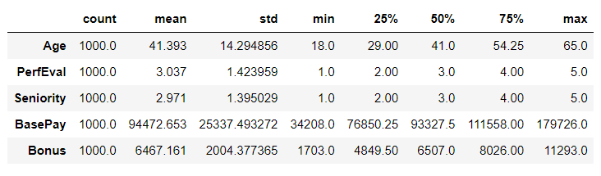

Frequencies of the categorical variables in our dataset:

* JobTitle: There are 10 job titles in the dataset, with "Marketing Associate" being the most common, appearing 118 times.
* Gender: There are two categories: "Male" and "Female," with "Male" being the most frequent, totaling 532 records.
* Education: There are four educational levels, with "High School" being the most common, with 265 records.
* Dept: There are five departments, with "Operations" being the most common, with 210 records.

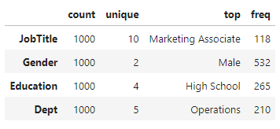

#### Salary:

The salary is calculated as sum of the base salary and the yearly bonus.



### Data Visualization:

Distribution Plots: Distribution plots were used to visualize salary distribution and other numeric variables.

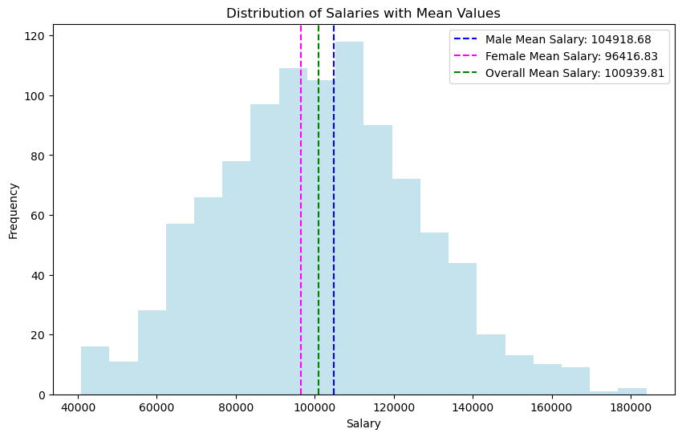

In the histograms, we observe the distribution of salaries for all individuals in the dataset, alongside their respective mean values for both men and women.

Mean Salary:

* For the overall dataset: $100,939.814
* For men: $104,918.68
* For women: $96,416.83

These results provide a comprehensive view of the salary distribution within the dataset. We can observe that the mean salary for men is higher than that for women, indicating a potential gender disparity. This trend is consistent with the mean salary reflecting a higher average salary for men compared to women.

Pair Plots: Pair plots visually explore relationships between variables, using color to distinguish between categorical and numeric variables. This helps identify patterns, including those related to the gender pay gap, by showing how salary varies across different groups like men and women. 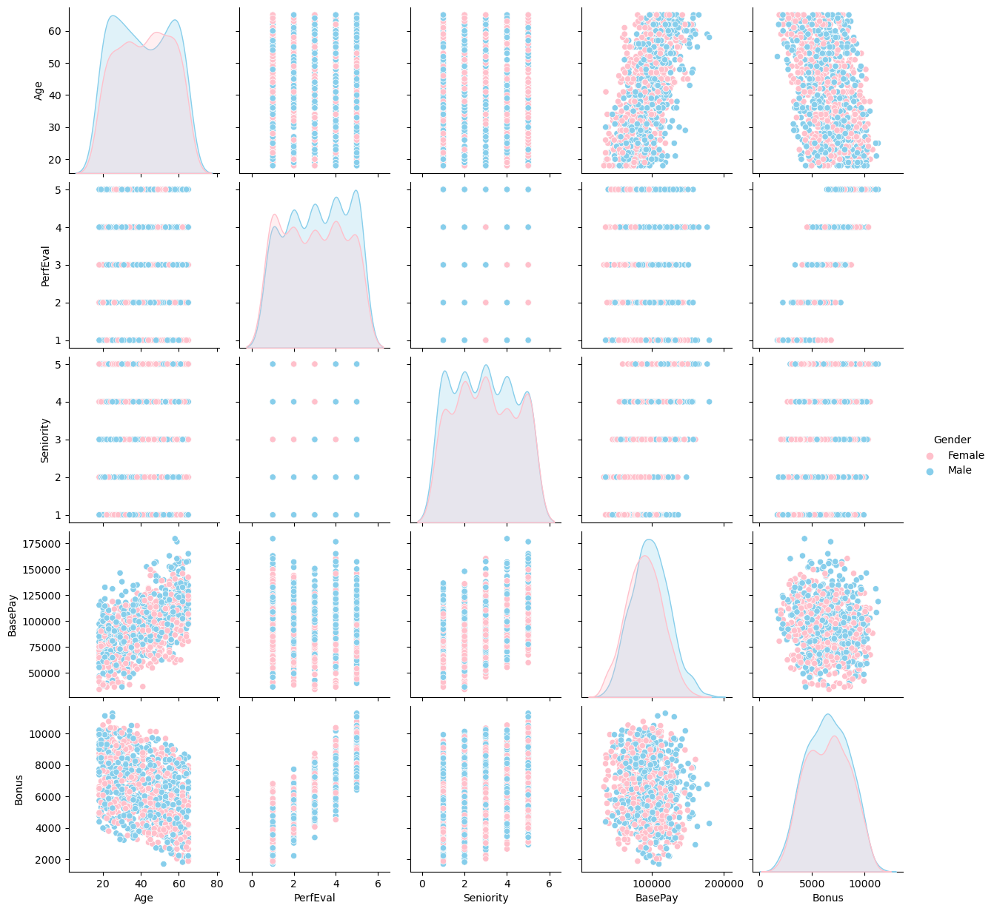

### Model Performance:

Correlation Analysis: A correlation matrix was calculated to understand relationships between variables like gender, job position, and salary. It revealed moderate positive correlations between age, seniority, and salary. Additionally, significant correlations were found between performance evaluation, base pay, and bonus. Visualizing these correlations with a heatmap highlighted strong relationships, such as those between salary and age, and salary and base pay.

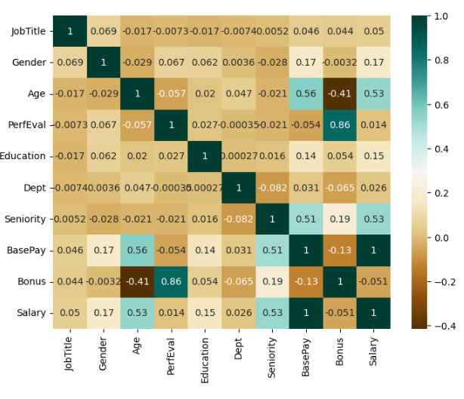

### Pre-processing

#### Handling Missing Values:

**No missing values** were detected in any of the variables in the dataset, as confirmed during the data exploration phase. Therefore, no correction or removal of missing values is required.

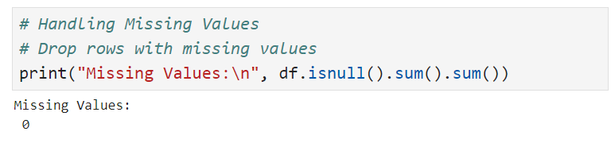

##### Encoding Categorical Variables:

To facilitate the analysis of the dataset, categorical variables were encoded into a numerical format. In our dataset, we identified four categorical variables: "Job Title," "Gender," "Education," and "Department".

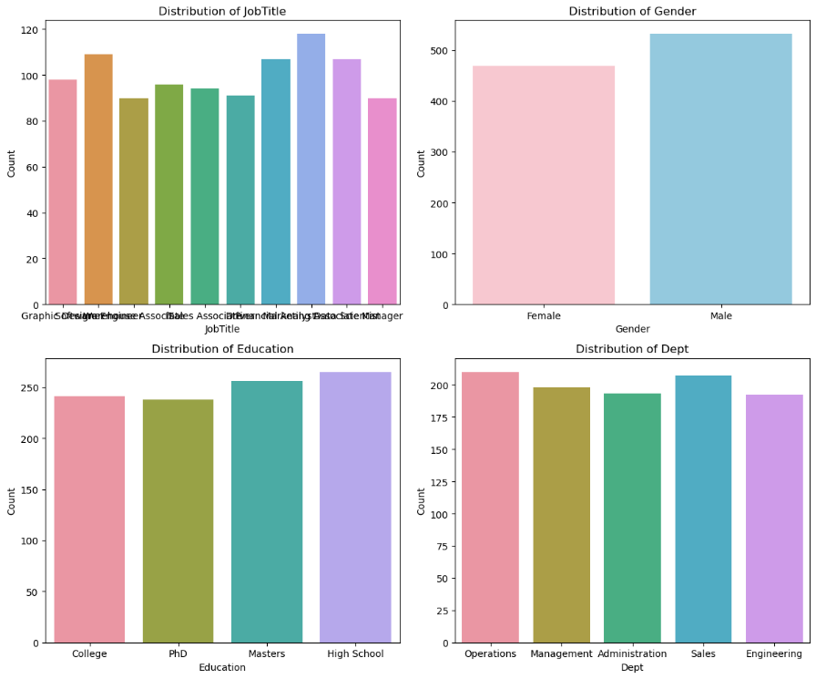

The label encoding method was used to transform these variables into numerical values. The results of this encoding are shown at the end, allowing for more effective use of the data in subsequent analyses.

##### Scaling Numeric Features:

Scaling was applied to numeric features to ensure all variables were on the same scale and contributed equitably to the analysis.

##### Outlier Detection and Removal:

Outliers were identified and removed to mitigate potential negative effects on the pay gap analysis.

## Implementation and Evaluation of Machine Learning Models

### Classification Models:

A list of classification machine learning models, including Logistic Regression, K Nearest Neighbors (KNN), Decision Tree, Random Forest, and Support Vector Machines (SVM), were evaluated to predict female workforce participation. This variety of models is chosen to compare and select the most suitable one for the dataset at hand.

Each model is evaluated using ***stratified cross-validation*** with 5 folds. Cross-validation provides more accurate estimates of model performance by training and testing the model on multiple data subsets. The average accuracy and standard deviation of each model during cross-validation are printed to assess their stability and performance. Finally, the performance comparison of the algorithms is visualized using a box plot.

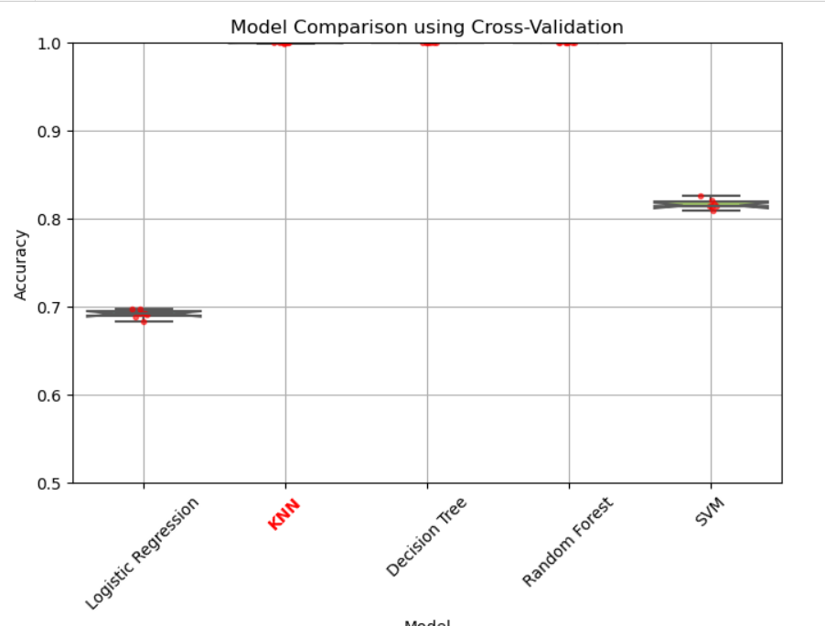

Finally, the performance comparison of the algorithms is visualized using a box plot. This graph allows identifying differences in the distribution of performance among the evaluated models, aiding in selecting the most suitable model for the classification problem.

### Development K Nearest Neighbors (KNN) - model with the best accuracy score

The K Nearest Neighbors (KNN) model was chosen for classification based on comparing different models. Selecting the right model is crucial for ensuring optimal performance of the classification system.

The chosen model is trained using the entire training dataset. This step is critical for the model to learn the relationships between predictor variables and the target variable. Training the model is essential for its predictive capability. Additionally, an analysis is conducted to determine the importance of features in the model.

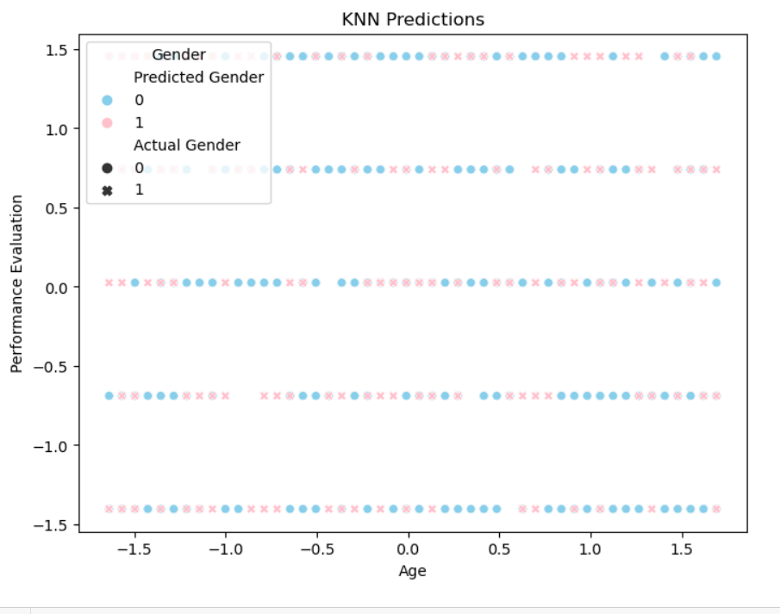

**Prediction and Model Evaluation:** The trained model is used to make predictions on the validation dataset. Subsequently, its performance is evaluated using metrics such as accuracy and the confusion matrix.

### Visualization of the Confusion Matrix:

The confusion matrix is visualized using a heatmap. This graphical representation helps understand the relationships between the model's predictions and the actual classes.

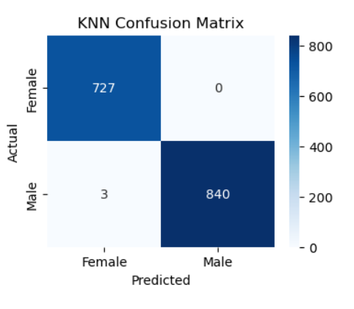

## Conclusion

Data Analysis: A comprehensive analysis of salary data across different job positions, categorized by gender, was conducted. This analysis revealed a series of significant trends that provide valuable insights into potential gender salary disparities in the studied labor sector.

Exploratory Data Analysis (EDA): Exploratory data analysis revealed a trend towards possible gender salary disparity, evidenced by differences in the median, mode, and mean of salaries. Additionally, salary ranges for men and women in each department were examined, revealing possible salary differences between departments.

Machine Learning: Various machine learning models were evaluated to predict female labor participation, with the K Nearest Neighbors (KNN) model highlighted as the most effective for the specific dataset. This model demonstrated 99.8% accuracy in predicting female labor participation in the test set.

## Recommendations

Based on the findings of the analysis, the following recommendations are formulated:

Detailed Analysis of Salary Gaps: Given that exploratory data analysis revealed significant differences in salaries by gender in certain departments and experience levels, conducting a more detailed analysis to identify the underlying causes of these disparities is recommended. This may involve investigating factors such as compensation structure, promotion policies, and role distribution within the company.

Review of Policies and Procedures: Based on the identified salary gaps, it is suggested to review the company's policies and procedures related to compensation and promotion. It is important to ensure that these processes are transparent, equitable, and free from gender bias. Additionally, the implementation of specific measures to address any identified salary disparities should be considered.

Gender Equity Awareness: Since the analysis highlighted the importance of raising awareness about gender equity in the workplace, implementing awareness programs targeting all levels of the organization is recommended. These programs may include training sessions on unconscious bias, diversity and inclusion, as well as promoting an inclusive work environment where all voices are valued.

Continuous Monitoring and Impact Evaluation: To ensure that the measures taken are effective in reducing gender salary gaps, establishing a system for continuous monitoring and impact evaluation is recommended. This involves continuing to collect salary data disaggregated by gender and conducting periodic analyses to assess progress towards salary equity. The results of these evaluations should inform additional adjustments to company policies and practices.

## Github

<https://github.com/CCT-Dublin/capstone-project-feb-2024-ft-YumikoBejarano>

# References

Chapman, P., Clinton, J., Kerber, R., Khabaza, T., Reinartz, T., Shearer, C. and Wirth, R. (2000). Step-by-step data mining guide. [online] Available at: https://www.the-modeling-agency.com/crisp-dm.pdf.

Chatgpt.com. (2024). Available at: https://chatgpt.com/share/681cfb33-4726-43ca-8d24-3a2431901e84 Get instant answers, find inspiration, learn something new.

Kazil, J. and Jarmul, K. (2016). Data Wrangling with Python: Tips and Tools to Make Your Life Easier. [online] Google Books. ‘O’Reilly Media, Inc.’ Available at: https://books.google.ie/books?id=XmeDCwAAQBAJ&printsec=copyright&redir_esc=y#v=onepage&q&f=false [Accessed 22 May 2024].

Müller, A.C. and Guido, S. (2017). Introduction to machine learning with Python : a guide for data scientists. Beijing: O’reilly.

Peng, R.D. and Matsui, E. (2015). The art of data science : a guide for anyone who works with data. Victoria, British Columbia: Lulu.com.

Python, R. (n.d.). Using k-Nearest Neighbors (kNN) in Python – Real Python. [online] realpython.com. Available at: https://realpython.com/courses/knn-python/ [Accessed 22 May 2024].

VanderPlas, J. (n.d.). Handling Missing Data | Python Data Science Handbook. [online] jakevdp.github.io. Available at: https://jakevdp.github.io/PythonDataScienceHandbook/03.04-missing-values.html.